**Foreign Parts Screen**

This is a custom menu item maintenance program that allows the user to enter parts bought from a foreign supplier. This screen will have a locked Part, Rev, and Loc textboxes with a browser button beside it.

The Parts browser button will display a browser with Parts from Inventory Master. When the user selects a Part, the Part, Rev, and Loc textboxes will be filled with the Part chosen. After the Part is selected the Part Information Textboxes/Checkboxes will need to be populated. This will include the HTSUS No., HTSUS Rate, HTSUS Description, HTSUS Weight, Conversion Factor, HTSUS UM, AD/CVD Case No. AD/CVD Rate, Form ID, Country of Origin, Location Code (Not the same as a Part Location), and Zone Status. This information will be associated with the part.

Below the textboxes will be an Add button which will not be active till the Part Information has been filled in.

Pressing the Add button will add the Part to the Foreign Parts table, then update the grid on screen with the latest table contents if the Part does not already exist in the table/grid.

If the Part already exist in the table/grid, the user will be notified. This notification will allow for the part information to be edited if needed by populating the Part Information textboxes, and removing the Part from the Grid. This grid contains all fields from the Foreign Parts table: Part, HTSUS No., HTSUS Rate, HTSUS Description, HTSUS Weight, Conversion Factor, HTSUS UM, AD/CVD Case No. AD/CVD Rate, Form ID, Country of Origin, Location Code (Not the same as a Part Location), Zone Status, and a Remove button at the end of each row.

The Zone Status column is a multi-value column. Zone Status values can be one or more of the following: “NPF”, “PF”, “D”, and “ZR”. Zone Status will be “NPF” default. For example, if the “PF” and “D” checkboxes are checked and the others are not, the Zone Status cell will display “PF, D”.

The Remove button in the grid will delete the corresponding row from the table then update the grid with the latest table contents.

Notes for the Programmer:

Current Program: PPT_3613_ForeignParts.gas

To prevent possible data saving issues, when a remove button is pressed, save all the data that is currently in the grid to the table before attempting to delete a record.

Zone Status should be saved as an integer in the table. The values are as follows: NPF (1), PF (2), D (4), ZR (8) and the integer store will be a sum of the values. To complete this, use F.In.Variable.BitArrayToLong. Pass the function an array of Booleans based on which checkboxes where checked. It's important that these values are passed in the same order every time. Because, for example, if “PF” and “D” is checked, you must pass the function an array of bool like: [0,1,1,0] = NPF(False), PF(True), D(True), ZR(False) and resulting Long value will be: 6, that is PF(2) + D(4). To return which values were checked, use F.In.Variable.LongToBitArray, which will take the Long value and returns an array of Booleans in the order they were passed. No need to split by a delimiter because the value is passed as an array already.

Table: PPT_3613_ForeignPart

Fields [Field Name (Type: Size/Precision, Scale)]:

Part (CHAR 17)

Rev (CHAR 3)

Loc (CHAR 2)

HTSUS_No (VARCHAR 12)

HTSUS_Rate (NUMERIC 8, 4)

HTSUS_Desc (VARCHAR 30)

HTSUS_Weight (NUMERIC 8, 4)

Conversion_Factor (NUMERIC 14, 8)

HTSUS_UM (VARCHAR 6)

AD_CVD_Case (VARCHAR 20)

AD_CVD_Rate (NUMERIC 8, 4)

Form_ID (VARCHAR 5)

Origin_Country (CHAR 2)

Loc_Code (VARCHAR 6)

Zone_Status (TINYINT)

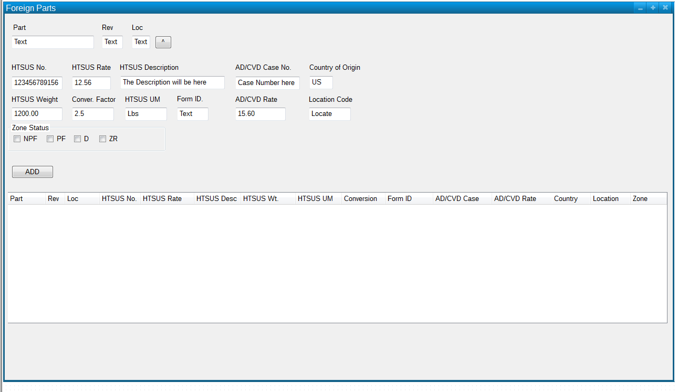

**Taxes Paid Parts Screen**

This is a custom menu item maintenance program that allows the user to update the quantity of foreign parts with taxes paid. This screen will have a grid filled with Parts from the Foreign Parts table and Taxes Paid table. If a Part no longer exist in the Foreign Parts table but still has quantity in the Taxes Paid table, it will remain in the table until the quantity equals 0 when it will then be removed. The grid will contain fields:

Part

Rev

Loc

Quantity

All fields will be locked except Quantity. The user will be able to modify the Quantity for each Part in the grid. Below the grid will be a Save and Refresh button.

The Save button will upload the changes in the grid to the Taxes Paid table.

The Refresh button will update the grid in the event Parts are added to the Foreign Parts table while the Taxes Paid screen is open.

Notes for the Programmer:

Current Program: PPT_3613_Taxes_Paid.gas

How to fill the Grid:

Part (PPT_3613_Taxes_Paid.Part)

Rev (PPT_3613_Taxes_Paid.Rev)

Loc (PPT_3613_Taxes_Paid.Loc)

Quantity (PPT_3613_Taxes_Paid.Qty)

Delete Parts from the Taxes Paid table where Qty = 0. If they still exist in the Foreign Parts table, the Parts will be returned with the following query for the user to add a quantity to it, otherwise all the Parts are used up and no longer need to appear in the grid. Use this query to populate the grid:

Select * From (Select Part, Rev, Loc From PPT_3613_ForeignPart Union Select Part From PPT_3613_Taxes_Paid) fp Left Join PPT_3613_Taxes_Paid tp on fp.Part = tp.Part AND fp.Rev = tp.Rev AND fp.Loc = tp.Loc

Table Name: PPT_3613_Taxes_Paid

Fields:

Part (CHAR 17)

Rev (CHAR 3)

Loc (CHAR 2)

Qty (INTEGER)

This screen is currently fine as is, except the Quantity Change Logging which needs to be removed from the script. I just wanted to document what I did since it was not quoted.

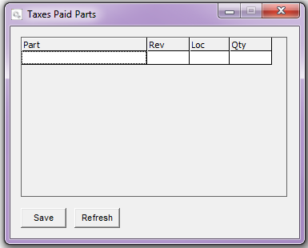

**Estimated Ship Quantity Screen**

This is a custom menu item reporting program used to generate part quantity reports. This screen will have a locked Part, Rev, and Loc textbox with a browser button beside it.

The Parts browser button will display a browser with Parts from Inventory Master. When the user selects a Part, the Part, Rev, Loc textboxes will be filled with the Part number chosen. Below the Part textbox will be an Add button.

When the user presses Add, the grid below, with columns: Part and Quantity, will be populated. The selected Part, if a BOM, will be exploded and only the Parts that are also in the Foreign Parts table will be added to the grid. The quantities for each part will be generated from the usage.

The largest value out of usage will be selected then multiplied by 1.3 and fill the Quantity field in the grid.

The user can add as many Parts to the grid as they want, but duplicate Parts should be omit. For example, if several different Parent Parts share the same Child Part, that Child Part and Quantity will only get added to the grid once.

Below the grid will be a Save and an Export button. The user must press the Save button to save the information that is in the grid to the Ship Quantity table. The Export button will generate a Crystal Report based on the information in the table.

Notes for the Programmer:

It is possible for the Parent Part to be in the Foreign Parts table so check for it as well.

Save the grid before Exporting, just in case.

The custom menu item for this program must be of type: Report. A report ID must be created then the GAB script is then attached to the report. The report number generated is what is selected when making the custom menu item manually.

If a BOM, will be exploded and only the Parts that are also in the Foreign Parts table will be added to the grid. The quantities for each part will be generated from the usage information in INVENTORY_MSTR.QTY_USAGE_MO_01 through INVENTORY_MSTR.QTY_USAGE_MO_10.

The largest value out of the QTY_USAGE_MO_... fields will be selected then multiplied by 1.3 and fill the Quantity field in the grid.

Table Name: PPT_3613_Ship_Qty

Fields:

Part (CHAR 17)

Rev (CAHR 3)

Loc (CHAR 2)

Qty (INTEGER)

Table Name: Z_PPT_3613_Ship_Qty

Fields:

BIRUNID (BIGINT)

Part (CHAR 17)

Rev (CAHR 3)

Loc (CHAR 2)

Qty (INTEGER)

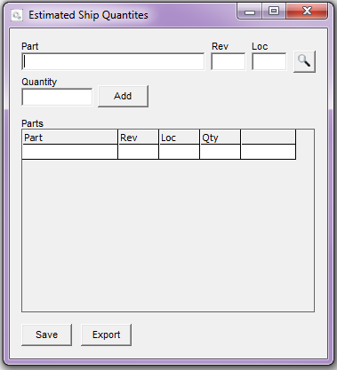

**Freight Zone Screen**

This is a custom menu item maintenance program that allows the user to create/edit a zone, add containers, and fill in additional information. The additional information on this screen will be stored in a custom table.

The user must select an existing or create a new zone before the other fields are enabled. There will be a Zone Admission dropdown filled with existing Zone Admission numbers and a New button beside it. To create a new zone, the user must press the New button. A Zone Admission number will be auto generated, added to the dropdown, and a new record will be added to the Freight Zone table.

The formula for H.J.'s Zone Admission number is:

1020E01 – these are the first 7 characters every time

YY – 2 digit year is next

CCC – company code

00001 – 5 digit counter, so it will be 00001, 00002, 00003, ….

A complete Zone Admission number would look like this: 1020E0116HJE00001

Once a Zone Admission number is selected, the other fields on the screen will become enabled. Below the Zone Admission dropdown will be rows of textboxes and datepickers the user has the option to populate:

In Bond No. (PPT_3613_FreightZone.InBond_No)

Bill of Lading (PPT_3613_FreightZone.BOL)

CBP Seal No. (PPT_3613_FreightZone.CBP_Seal_No)

Number of Packages (PPT_3613_FreightZone.Packages)

US POU (PPT_3613_FreightZone.US_POU)

FG POL (PPT_3613_FreightZone.FG_POL)

Import Carrier (PPT_3613_FreightZone.Import_Carrier)

Bonded Carrier (PPT_3613_FreightZone.Bonded_Carrier)

Export Date (PPT_3613_FreightZone.Export_Date)

Import Date (PPT_3613_FreightZone.Import_Date)

The user will also have access to add new, modify or remove existing Containers in the zone. There will be a locked Container textbox with a browser button and below the textbox will be an Add button.

If Container records already exist in the Zone Container table for the selected Zone Admission, the Containers grid, below the Container textbox, will be populated with information from various tables. The fields are:

Container (V_PO_CONTAINERS.CONTAINER)

Purchase Order (V_PO_CONTAINERS.PO)

Manufacturer ID (PPT_3613_MfgID.MfgID where V.PO_HEADER.VENDOR = PPT_3613_MfgID.Vendor)

Establishment ID (PPT_3613_EstID.EstID) There will be only one value in the table to choose from

Invoice No. (PPT_3613_Containers.Invoice_No)

Dutiable Value ( PPT_3613_Containers.Dutiable_Value)

Harbor Fee (PPT_3613_Containers.Harbor_Fee)

Only fields Invoice No. and Dutiable Value are editable. The other fields are locked. The last column in the grid will contain a Remove button. When click, the Container in the row selected will be removed from the grid and Zone Container table.

There will be a checkbox labeled: “Air Freight” right above the Containers grid. If checked, the Harbor Fee for all the Containers in the given Zone will default to 0. Otherwise Harbor Fee is calculated by multiplying Dutiable Value by 0.125.

The Containers browser button will display a browser with Containers from PO_CONTAINERS. When the user selects a Container, the Container textbox will be filled with the Container number chosen.

Pressing the Add button while the Container textbox is populated will add corresponding information to the Zone Container table, then update the Container grid below with content from various tables only if the Container does not already exist in the Zone Container table.

Also, a Container can only exist in one zone at a time. If the user attempts to add a Container to a zone but the Container already exist in a different zone, the user will be notified with the Zone Admission number that the Container exist in and asked if they want to move the container to the new zone.

The Container grid fields are populated from the tables mentioned above. The fields: Invoice No. and Dutiable Value are initially blank and 0, respectively. When those fields are modified in the grid, the values will be saved to the Zone Containers table upon cell exit.

The Harbor Fee calculation was explained above. Its value will be saved to the Zone Containers table upon Container Add or Air Freight checkbox value change.

At this time the Zone Parts table, PPT_3613_ZoneParts, will also be populated with some Part information for the given container. Only the Lines where the Part is also in the Foreign Parts table, PPT_3613_ForeignPart, should be included in the grid.

Below the Containers grid will be the Parts grid. Clicking on any column of a row in the Containers grid will fill the Parts grid with all the Lines corresponding with the Purchase Order for the Container. The Parts grid will be populated from various tables. The fields are:

Line (V_PO_CONTAINERS.PO_LINE)  
Part (V_PO_LINES.PART)

Part Description (V_PO_LINES.DESCRIPTION)

COO (PPT_3613_ForeignPart.Origin_Country)

Qty Ordered (V_PO_LINES.QTY_QRDER)

Qty Received (V_PO_LINES.QTY_RECEIVED)

Variance (Value of Variance: V_PO_LINES.QTY_QRDER minus V_PO_LINES.QTY_RECEIVED)

Qty In Inventory (PPT_3613_ZoneParts.Qty_In_Inv)

HTSUS No. (PPT_3613_ForeignPart.HTSUS_No where V_PO_LINES.PART = PPT_3613_ForeignPart.Part)

The Qty Received will be 0 if the Container has not yet been received. The Qty In Inventory will also be 0 and will be updated from P.O. Receipts when the Container is received.

All the fields in the Parts grid are locked and not editable.

Below the Parts grid will be an Additional Part Information grid. The information will be displayed in the same Line order as the Parts grid. This grid will contain more information about the Parts in the Parts grid The fields are:

HTSUS No. (PPT_3613_ForeignPart.HTSUS_No)

HTSUS Description (PPT_3613_ForeignPart.HTSUS.Desc)

HTSUS Rate (PPT_3613_ForeignPart.Rate)

HTSUS UM (PPT_3613_ForeignPart.HTSUS_UM)

HTSUS Qty (Value of HTSUS Qty: V_PO_LINES.QTY_RECEIVED * PPT_3613_ForeignPart.Conversion_Factor)

HTSUS Weight (Value of HTSUS Weight: V_PO_LINES.QTY_RECEIVED * PPT_3613_ForeignPart.Conversion_Factor * PPT_3613_ForeignPart.HTSUS_Weight)

AD/CVD Case No. (PPT_3613_ForeignPart.AD_CVD_Case)

AD/CVD Rate (PPT_3613_ForeignPart.AD_CVD_Rate)

Form ID (PPT_3613_ForeignPart.Form_ID)

Location Code (PPT_3613_ForeignPart.Loc_Code)

Zone Status (PPT_3613_ForeignPart.Zone_Status [returned in the format ie. “PF, D”])

All the fields in the Additional Part Information grid are locked.

Notes for the Programmer:

The formula for H.J.'s Zone Admission number is:

1020E01 – these are the first 7 characters every time

YY – 2 digit year is next

CCC – company code

00001 – 5 digit counter, so it will be 00001, 00002, 00003, ….

Zone

In Bond No. (PPT_3613_FreightZone.InBond_No)

Bill of Lading (PPT_3613_FreightZone.BOL)

CBP Seal No. (PPT_3613_FreightZone.CBP_Seal_No)

Number of Packages (PPT_3613_FreightZone.Packages)

US POU (PPT_3613_FreightZone.US_POU)

FG POL (PPT_3613_FreightZone.FG_POL)

Import Carrier (PPT_3613_FreightZone.Import_Carrier)

Bonded Carrier (PPT_3613_FreightZone.Bonded_Carrier)

Export Date (PPT_3613_FreightZone.Export_Date)

Import Date (PPT_3613_FreightZone.Import_Date)

Container

Container (V_PO_CONTAINERS.CONTAINER)

Purchase Order (V_PO_CONTAINERS.PO)

Manufacturer ID (PPT_3613_MfgID.MfgID where V.PO_HEADER.VENDOR = PPT_3613_MfgID.Vendor)

Establishment ID (PPT_3613_EstID.EstID) There will be only one value in the table to choose from

Invoice No. (PPT_3613_Containers.Invoice_No)

Dutiable Value ( PPT_3613_Containers.Dutiable_Value)

Harbor Fee (PPT_3613_Containers.Harbor_Fee)

PO

Line (V_PO_CONTAINERS.PO_LINE)  
Part (V_PO_LINES.PART)

Part Description (V_PO_LINES.DESCRIPTION)

COO (PPT_3613_ForeignPart.Origin_Country)

Qty Ordered (V_PO_LINES.QTY_QRDER)

Qty Received (V_PO_LINES.QTY_RECEIVED)

Variance (Value of Variance: V_PO_LINES.QTY_QRDER minus V_PO_LINES.QTY_RECEIVED)

Qty In Inventory (PPT_3613_ZoneParts.Qty_In_Inv)

HTSUS No. (PPT_3613_ForeignPart.HTSUS_No where V_PO_LINES.PART = PPT_3613_ForeignPart.Part)

Parts

HTSUS No. (PPT_3613_ForeignPart.HTSUS_No)

HTSUS Description (PPT_3613_ForeignPart.HTSUS.Desc)

HTSUS Rate (PPT_3613_ForeignPart.Rate)

HTSUS UM (PPT_3613_ForeignPart.HTSUS_UM)

HTSUS Qty (Value of HTSUS Qty: V_PO_LINES.QTY_RECEIVED * PPT_3613_ForeignPart.Conversion_Factor)

HTSUS Weight (Value of HTSUS Weight: V_PO_LINES.QTY_RECEIVED * PPT_3613_ForeignPart.Conversion_Factor * PPT_3613_ForeignPart.HTSUS_Weight)

AD/CVD Case No. (PPT_3613_ForeignPart.AD_CVD_Case)

AD/CVD Rate (PPT_3613_ForeignPart.AD_CVD_Rate)

Form ID (PPT_3613_ForeignPart.Form_ID)

Location Code (PPT_3613_ForeignPart.Loc_Code)

Zone Status (PPT_3613_ForeignPart.Zone_Status [returned in the format ie. “PF, D”])

Table Name: PPT_3613_MfgID

Fields:

Vendor (CHAR 6)

MfgID (CHAR 15)

Table Name: PPT_3613_EstID

Fields:

EstID (CHAR 12)

The Manufacturer and Establishment ID tables will be filled manually by the user using the Pervasive Control Center.

Table Name: PPT_3613_FreightZone

Fields:

Zone_Admission (CHAR 17)

InBond_No (VARCHAR 25)

BOL (VARCHAR 35)

CBP_Seal_No (VARCHAR 10)

Packages (INTEGER)

US_POU (CHAR 5)

FG_POL (CHAR 5)

Import_Carrier (VARCHAR 20)

Bonded_Carrier (CHAR 12)

Export_Date (Date)

Import_Date (Date)

Table Name: PPT_3613_Container

Fields:

Container (VARCHAR 15)

Purchase_Order (CHAR 7)

Invoice_No (CHAR 6)

Dutiable_Value (NUMERIC 8, 4)

Harbor_Fee (NUMERIC 8, 4)

Zone_Admission (CHAR 17)

Table Name: PPT_3613_ZoneParts

Fields:

Container (VARCHAR 15)

Purchase_Order (CHAR 7)

Line (CHAR 4)

Part (CHAR 17)

Rev (CHAR 3)

Loc (CHAR 2)

Qty_In_Inv (NUMERIC 14, 5)

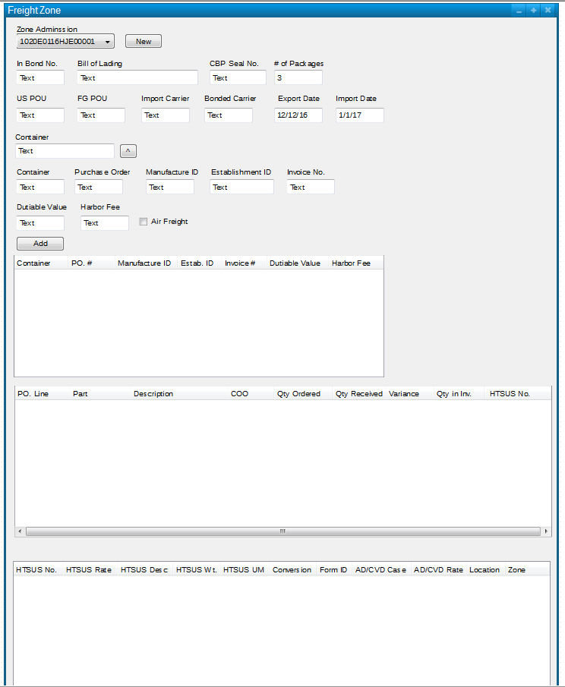

**Update Qty In Inventory**

This is a program that runs upon Purchasing > Transactions > P.O. Receipts to update the Qty In Inventory in the Zone Parts table for the given Purchase Order/ Container.

When the user presses OK on the P.O. Receipts screen, this program will first check to see if Parts include in the Purchase Order are in the Foreign Parts table. If none of the Parts are in the Foreign Parts table, the receiving process will continue as normal.

If there are Parts that exist in the Foreign Parts table, then the program will check for the Container and Purchase Order in the Zone Container table and for the Part in the Zone Parts table. If no zone records exist, the user will be notified and asked if they wish to continue.

If zone records do exist, then the corresponding PPT_3613_ZoneParts.Qty_In_Inv will be updated with the V_PO_LINES.QTY_RECEIVED value.

If everything in the Container does not have a record the user needs to be prompted asking if they wish to continue.

**Update Foreign Part Quantities in Taxes Paid and Containers**

This is a program that runs upon Shipment > New and Delete to update the part quantities in the Taxes Paid and Zone Parts tables. This program is responsible for deducting parts upon creating a shipment and adding back the parts upon deleting a shipment.

When a shipment is made, for each Part in the shipment, if it is a BOM it will be exploded and the Parent Part and its Children Parts will be checked against the Foreign Parts table. If a Part is a Foreign Part, the quantity shipped will be subtracted from the Taxes Paid quantity. It is possible for the Taxes Paid quantity to result in a negative number. The shipped quantity will also be subtracted from the Zone Parts table Qty In Inventory where the Part is in the oldest Container received. These quantities must not result in a negative number, but instead the difference should be subtracted from the next oldest container where Zone Parts Qty In Inventory is not equal zero.

If a shipment is deleted, the Part quantities must be added back to the Taxes Paid and Zone Parts tables.

The part quantities that were deducted from Zone Parts must return to the same Purchase Order/ Container they were deducted from.

When a shipment is made, information including the number of parts shipped will be written to the Quantities Log table. This table will be used to determine which Purchase Order/Container to add the parts shipped back to if a shipment is deleted.

Notes for the Programmer:

You will have to use the PO_HISTORY table DATE_RECEIVED to help determine which Purchase Order/Container to deduct from.

Table Name: PPT_3613_Qty_Log

Fields: Order_No (CHAR 7), Container (VARCHAR 15), Purchase_Order (CHAR 7), Line (CHAR 4), Part (CHAR 17), Rev (CHAR 3), Loc (CHAR 2), Quantity (NUMERIC 14, 5)

**Scrap and Adjustments**

This is a custom menu item maintenance and reporting program that allows the user to manually adjust the quantities of Parts in Zone Containers. Quantity changes will be recorded and the user will be able to generate a report of the adjustments.

First there will be a locked Part, Rev, and Loc textbox with a browser button beside it. The Parts browser button will display a browser with Parts from the Zone Parts table, PPT_3613_ZoneParts. When the user selects a Part, the Part, Rev, Loc textboxes will be filled with the Part number chosen. Below the Part textbox will be a Containers dropdown. When a Part is selected, the Container dropdown will be filled with all the corresponding Containers from the Zone Parts table.

Below the Container dropdown will be a Modify dropdown where the user can select either: “SCRAP” or “ADJUST”. Beside the Modify dropdown there will be a Reason dropdown where the user must select a reason before saving the adjustment.

The Reason dropdown will be populated with reasons from the Reasons table Text field, PPT_3613_Reasons.Text.

Beside the Reason dropdown will be a Quantity textbox where the user will enter a quantity by which to modify the Zone Part table Qty In Inventory. This field is only enabled when “ADJUST” is selected from the Modify dropdown.

Below these fields will be a Save button. The user must press the Save button to save the modifications they have made to the selected Part/Container.

When the Save button is pressed, if “Scrap” was selected, the Zone Part table Qty In Inventory for the Part/Container selected will be set to 0. If “Adjust” was selected, the Qty In Inventory will modified by the value in the Quantity textbox. That is, if a negative number is in the field, the Qty In Inventory will be decreased. At this time, there will also be a record written to the Adjustments table of the modifications.

Notes for the Programmer:

Table Name: PPT_3613_Reasons

Fields:

Code (CHAR 2)

Text (VARCHAR 30)

The Reasons table will be filled manually by the user using the Pervasive Control Center.

Table Name: PPT_3613_Mod_Log

Fields:

Part (CHAR 17)

Rev (CHAR 3)

Loc (CHAR 2)

Container (VARCHAR 15)

Modification (VARCHAR 6)

Quantity (NUMERIC 14, 5)

Reason_Code (CHAR 2)

Mod_Date (Date)

Modification should be either “SCRAP” or “ADJUST” based on the Modify dropdown selection.

**Shipment History**

At the point a shipment is made the Finished good being shipped along with the Quantity being shipped will be gathered. With this information the components associated with the Finished Good part will be looked into to see if any of them are on the Foreign Parts List. If they are then the Quantity of Foreign Parts will be calculated based on the Qty of Finished Good being shipped. Along with this information the Packing Number, Order Number, the Finished Good Part, Finished Good Quantity, Component Part, component quantity, User, Date, and Freight Zone will be stored to a Transaction History Table. If a Shipment is deleted then a Negative record will be written.

Tech:

Hook: 28530

Packing #: Passed.000168

Use BDF to get the Order number, Finished Good Part, and Finished Good Quantity: AUX001

History Table:

Packing_NO - Char

Order_NO - Char

FG_Part - Char

FG_Qty - Numeric

Comp_Part - Char

Comp_Qty - Numeric

FreightZone - Char

User - Char

Date - Date